Only use 1 Authoring Group:
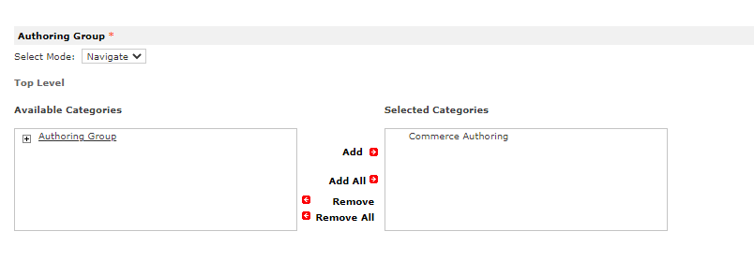
- Commerce Authoring

Do not press “Check out”

Reusable solution
Create repository on account: https://alm.oraclecorp.com/nscs/#projects/012-cs-common-customizations-ecom/
Enter on account: Commerce Solutions

Go to my code, then do “gulp extension:deploy –to –account tstdrv2509281” and deploy and activate my extension on Commerce Solutions account.
Then create the bundle:
Customization -> SuiteBundler -> Create Bundle
On Name set NSeComm | Customization name
On Installation script: NSeComm | Bundle Installation SS2
Abstract: fill up

On “Select objects” step:
Set Folder to the extension folder, to see the extension folder I have to edit the folder and set “Available to suitebundles” to true
